Java JUnit

Unit Testing
Unit testing is a critical part of software development, ensuring that individual components of the software work as expected. In Java, unit testing can be done using various frameworks, with JUnit being one of the most popular.

JUnit
- For setting up JUnit 5, add the Maven dependency junit-jupiter-api to your pom.xml file
- JUnit 5 provides annotations and assertions to help you write tests. Here are some basic annotations:
  - @Test: Marks a method as a test method.
  - @BeforeEach: Runs before each test method.
  - @AfterEach: Runs after each test method.
  - @BeforeAll: Runs before all test methods in the class (must be static).
  - @AfterAll: Runs after all test methods in the class (must be static).
- Simple example:
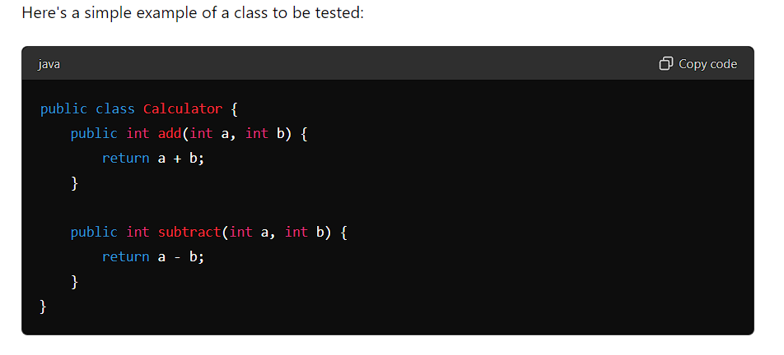
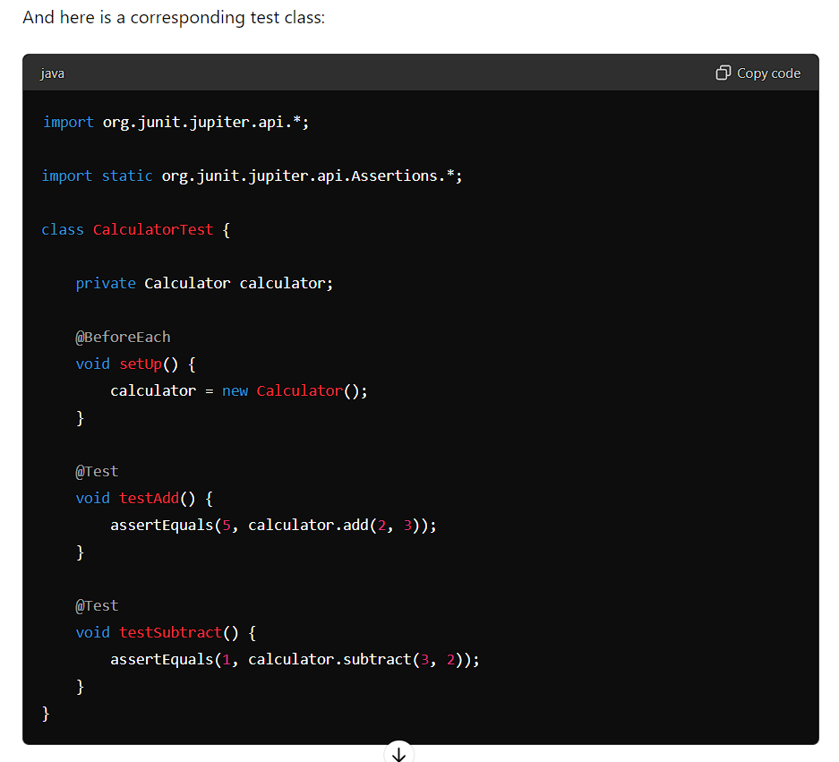

- JUnit provides a variety of assertions to check the expected results:
  - assertEquals(expected, actual): Asserts that two values are equal.
  - assertNotEquals(unexpected, actual): Asserts that two values are not equal.
  - assertTrue(condition): Asserts that a condition is true.
  - assertFalse(condition): Asserts that a condition is false.
  - assertNull(object): Asserts that an object is null.
  - assertNotNull(object): Asserts that an object is not null.
  - assertThrows(expectedTypeException, lambdaExecutable): Asserts that an executable throws a specific exception.
- assertThrows example: grade of negative marks scenario, ‘var’ is just new java 11 feature to replace class name, it uses lambda
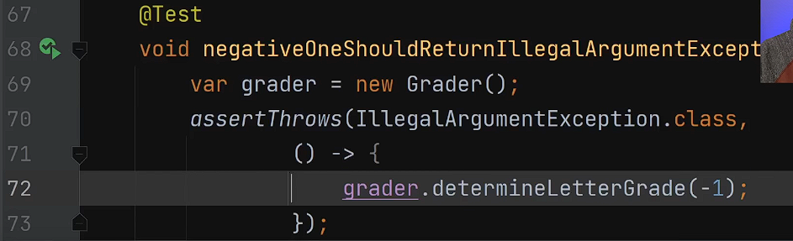
- JUnit 5 supports parameterized tests, allowing you to run a test multiple times with different parameters:
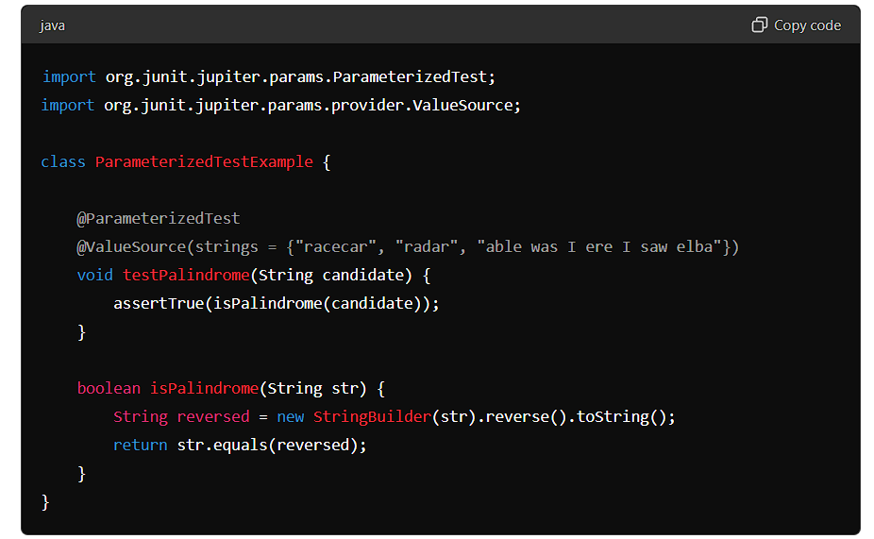
- Basic annotations of JUnit controlling lifecycle:
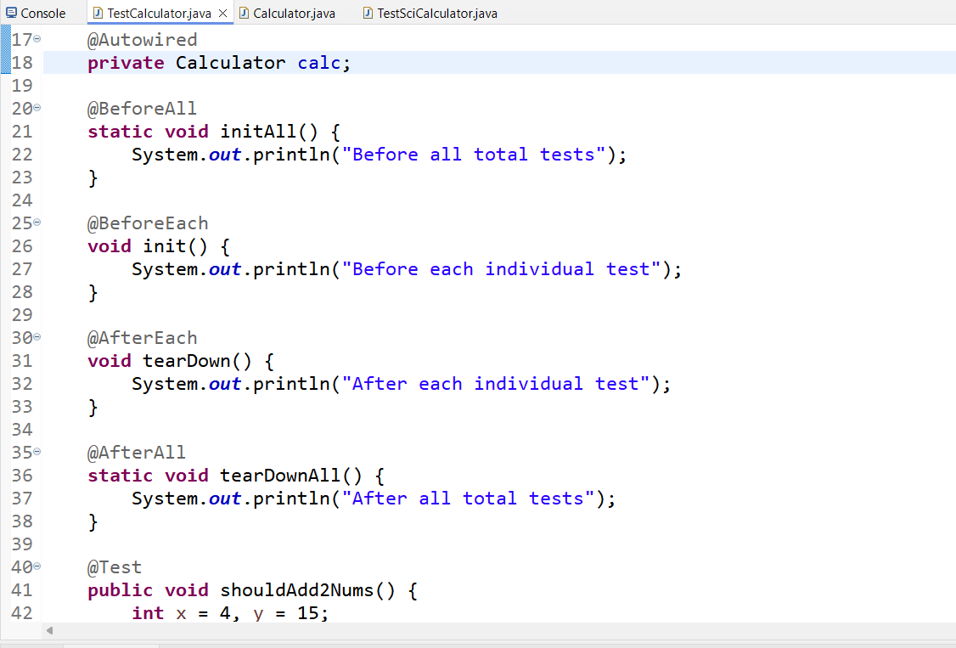

Springboot Application JUnit testing using Mockito Framework
- Mockito allows you to mock/imitate external dependencies like database and test your controllers, services, and repositories in isolation
- Steps are:
